Bulelani Mdolo
St10398023
Linear Regression
Date: 31 March 2026
POE PART 1
Module name: PDAN8411

Contents
Introduction 1
Data Description 1
Exploration Data Analysis (EDA) 2
Data Preparation 4
MODEL TRAINING 4
Model evaluation 5
MODEL IMPROVEMENT 5
CONCLUSION 5
REFERENCES 6

Introduction
This report presents the development and evaluation of a Linear Regression model to predict medical insurance charges based on individual characteristics such as age, body mass index (BMI), smoking status, and region. Understanding the factors that influence medical costs is important for insurance providers, as it allows for more accurate pricing strategies and risk assessment. The objective of this analysis is to explore the dataset, identify key relationships between variables, and develop a predictive model that can estimate medical charges with reasonable accuracy.

Data Description
The dataset used in this analysis contains demographic and health-related information for a few individuals. The variables include age, gender, BMI, number of children, smoking status, and region. These variables represent the features used to predict the target variable, which is “charges”. The target variable represents the medical insurance cost for each individual and is continuous in nature, making it suitable for regression analysis. The dataset consists of both numerical variables (such as age and BMI) and categorical variables (such as smoking status and region), requiring appropriate preprocessing before modelling. 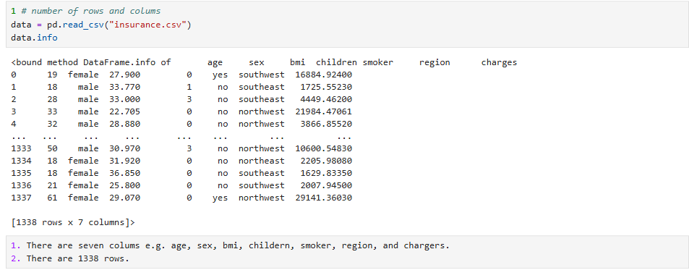

Exploration Data Analysis (EDA)
Exploratory Data Analysis (EDA) is conducted to gain insight into the structure and patterns within the dataset. This step is critical as it helps determine whether the data is suitable for modelling and identifies relationships between variables.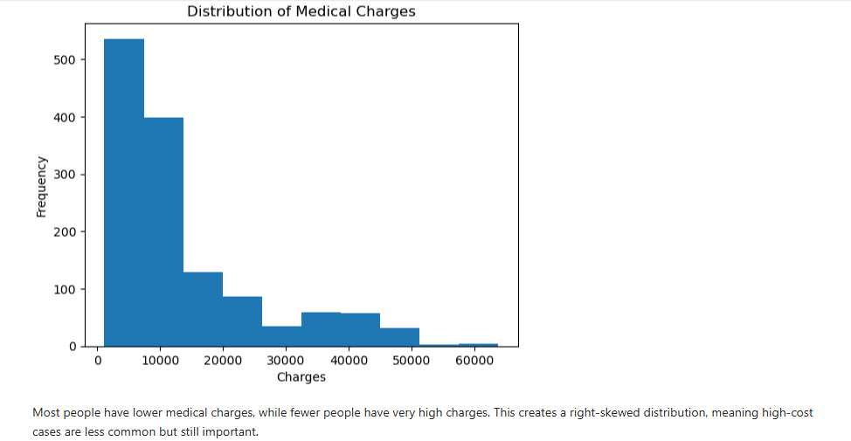
A strong relationship was observed between smoking status and medical charges. Smokers have significantly higher costs compared to non-smokers, indicating that smoking is a major factor influencing insurance pricing. 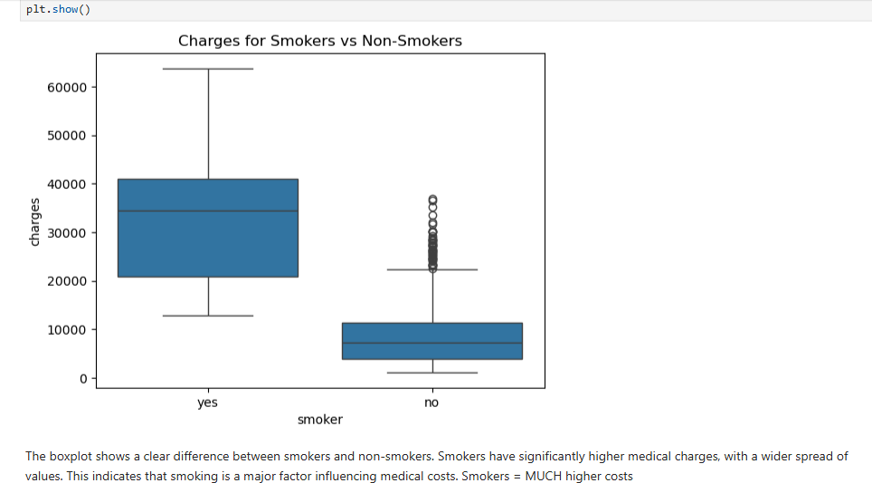
Scatter plots showed that age has a positive relationship with charges, meaning older individuals tend to have higher medical costs. BMI also shows some relationship with charges, although it is less strong compared to smoking. 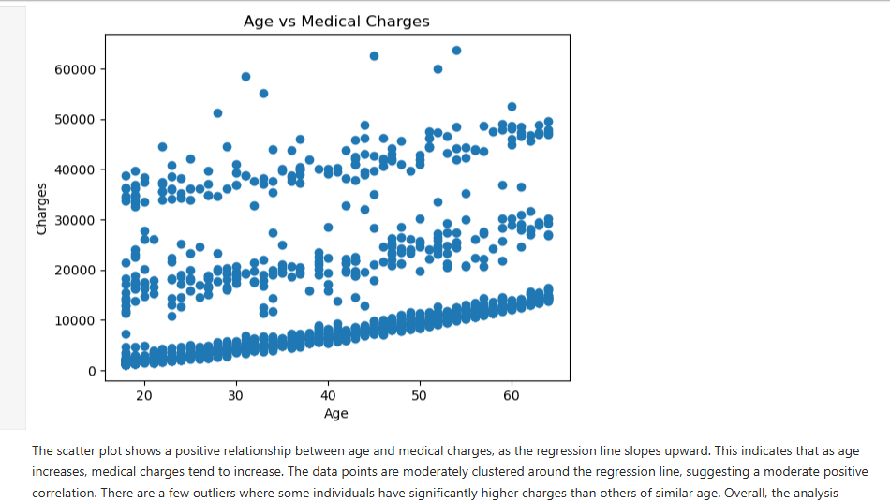
These findings suggest that features such as smoking status, age, and BMI are important predictors and should be included in the model.
Overall, the EDA findings suggest that smoking status, age, and BMI are key predictors of medical charges. These insights provide a strong foundation for building an effective regression model.

Data Preparation
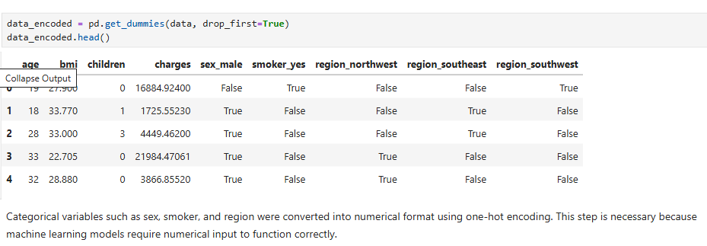
Before training the model, the dataset is pre-processed to ensure compatibility with the machine learning algorithm. Categorical variables such as gender, smoking status, and region is converted into numerical format using one-hot encoding. This transformation is necessary because regression models require numerical input. To evaluate the model’s performance, the dataset is split into training and testing sets using an 80/20 ratio. The training set is used to build the model, while the testing set is used to assess how well the model generalises to unseen data.

MODEL TRAINING
A Linear Regression model is selected for this analysis due to its simplicity. Linear Regression models the relationship between independent variables and a continuous dependent variable by fitting a linear equation to the observed data.
The model is trained using the training dataset, where it learned the relationships between the input features and medical charges. This process involves estimating coefficients for each feature, which represent their contribution to the predicted outcome.
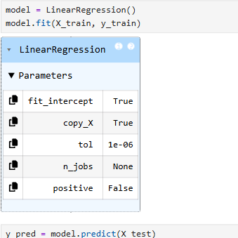

Model evaluation
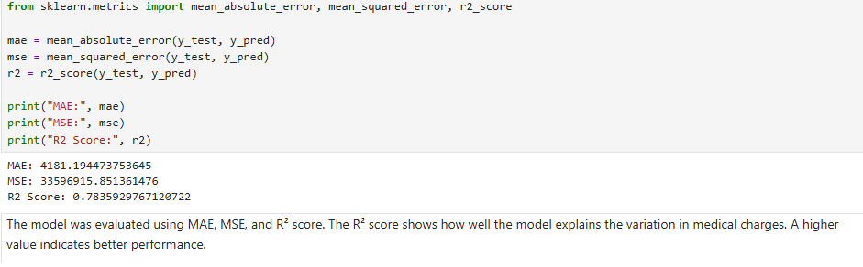The model is evaluated using Mean Absolute Error (MAE), Mean Squared Error (MSE), and the R² score. The R² score indicates how well the model explains the variation in medical charges. The results show that the model performs reasonably well, capturing key patterns in the data, although some variation remains unexplained.

MODEL IMPROVEMENT
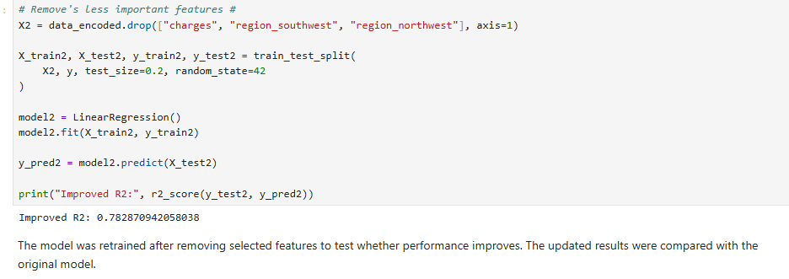
The model is further improved by modifying the feature set and retraining it. This is done to evaluate whether simplifying the model or removing less relevant variables would improve performance. The updated results were compared to the original model.

CONCLUSION
In conclusion, this analysis successfully explored the factors influencing medical insurance charges and developed a Linear Regression model to predict these costs. The results indicate that smoking status is the most significant predictor, followed by age and BMI.
The model demonstrates reasonable predictive capability, making it useful for understanding cost drivers in the dataset. However, further improvements could be achieved by exploring more advanced machine learning techniques or incorporating additional data features.

REFERENCES
- Introduction to Machine Learning with Python
Müller, A.C. and Guido, S., 2016. Introduction to Machine Learning with Python: A Guide for Data Scientists. Sebastopol: O’Reilly Media.
- Medical Cost Personal Dataset
Mirchio, M., 2018. Medical Cost Personal Dataset. [online] Available at: https://www.kaggle.com/datasets/mirichoi0218/insurance
- scikit-learn
Pedregosa, F. et al., 2011. Scikit-learn: Machine Learning in Python. Journal of Machine Learning Research, 12, pp.2825–2830.
- pandas
McKinney, W., 2010. Data Structures for Statistical Computing in Python. Proceedings of the 9th Python in Science Conference.
- Matplotlib
Hunter, J.D., 2007. Matplotlib: A 2D Graphics Environment. Computing in Science & Engineering, 9(3), pp.90–95.
- Seaborn
Waskom, M., 2021. Seaborn: Statistical Data Visualization. Journal of Open-Source Software.

